**29-04-2025 ASSIGNMENT – 1**

**CREATING A NEW REPOSITORY:**

First give repository name and then give a description for the repo

Make it public and add README file

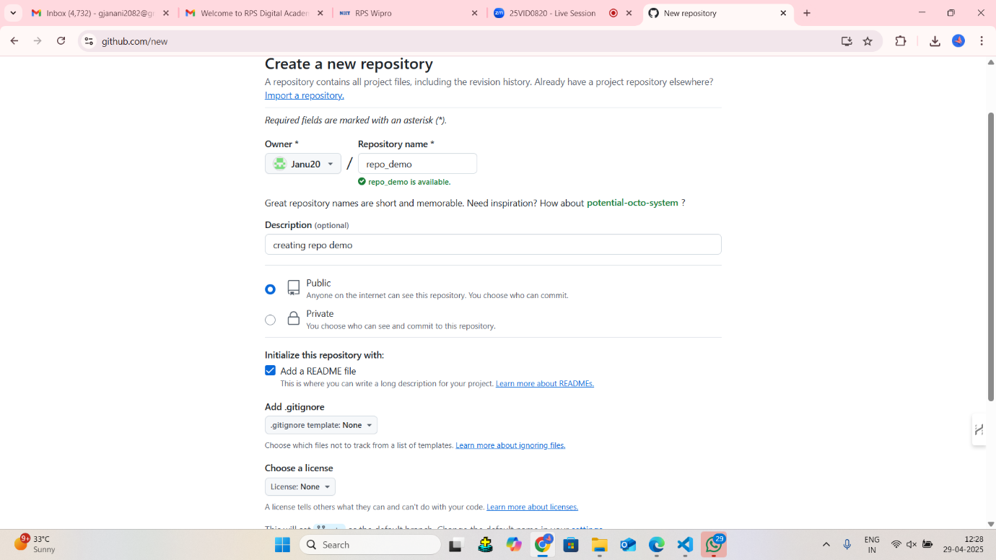

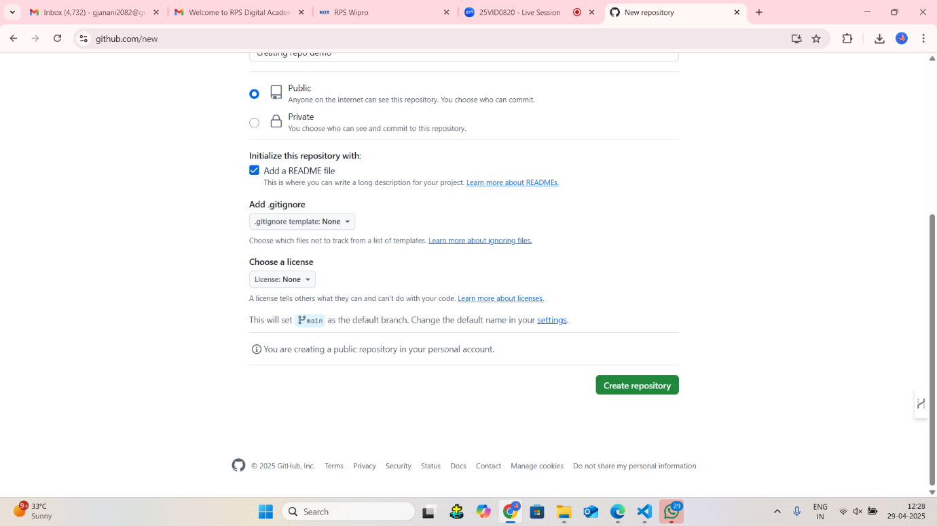

This is the repository we have created

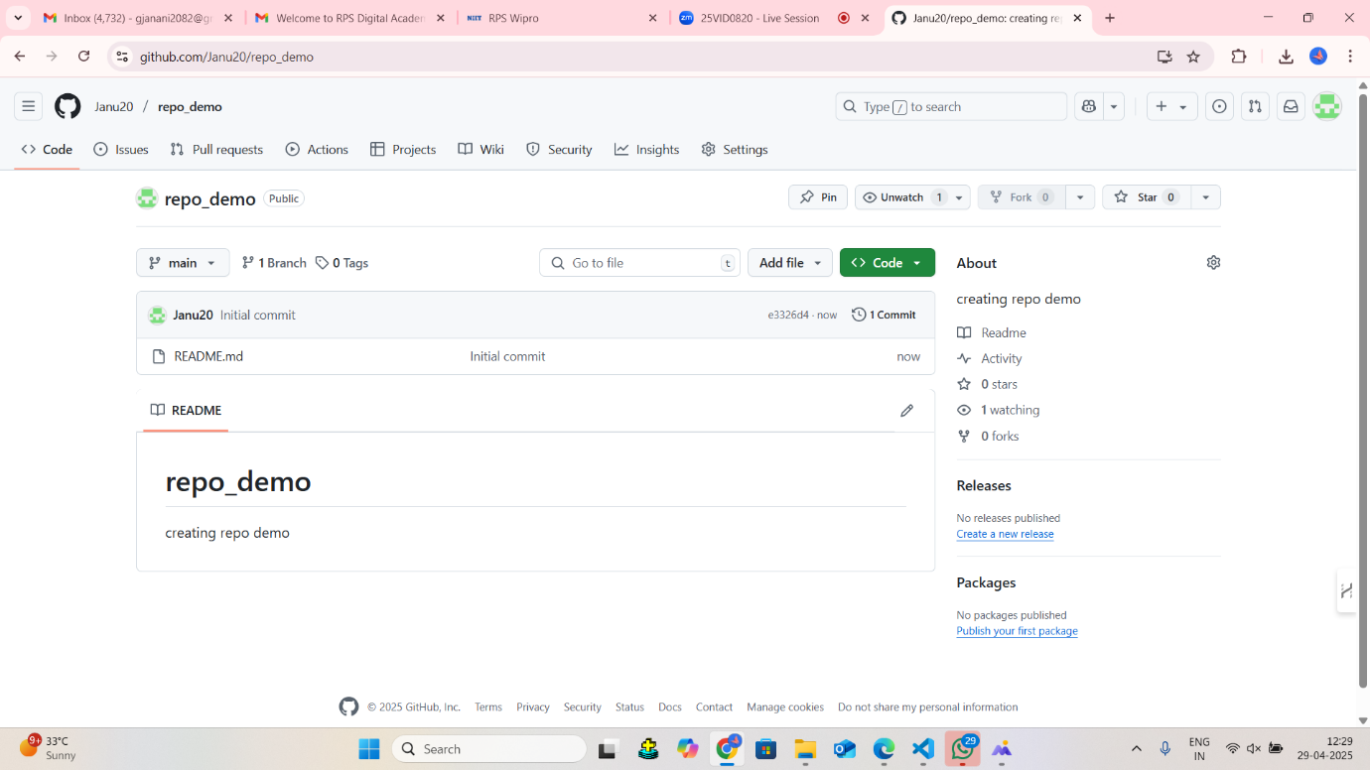

**CLONING:**

1. Copy the link under the <>code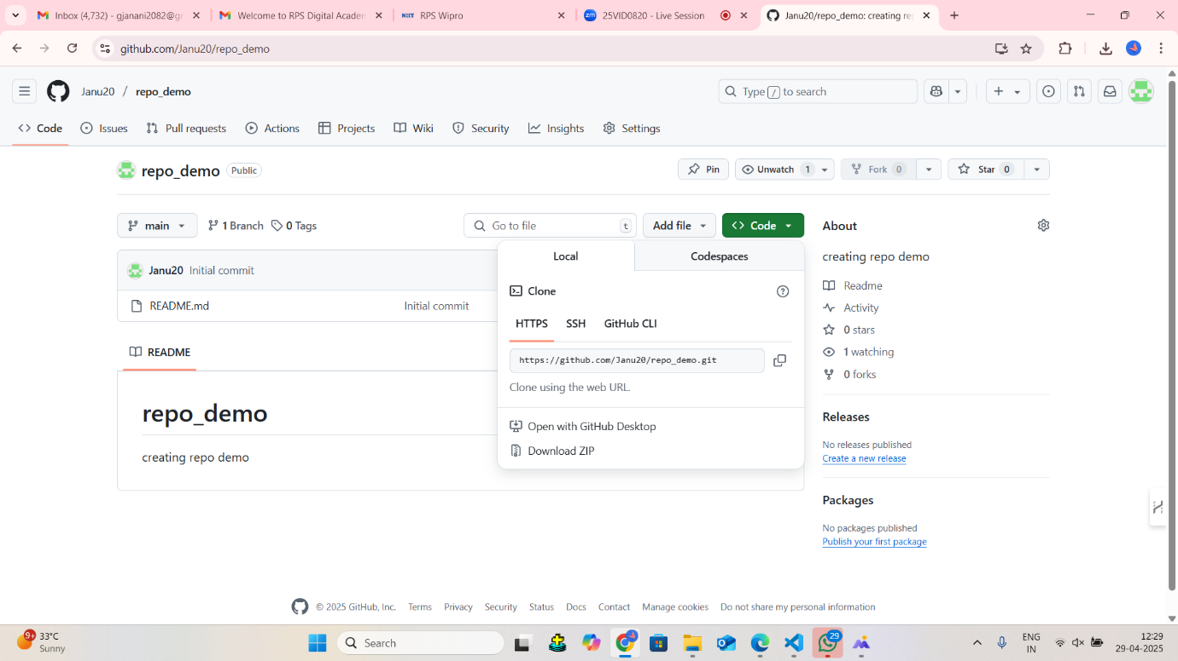
2. git clone [paste the copied link]

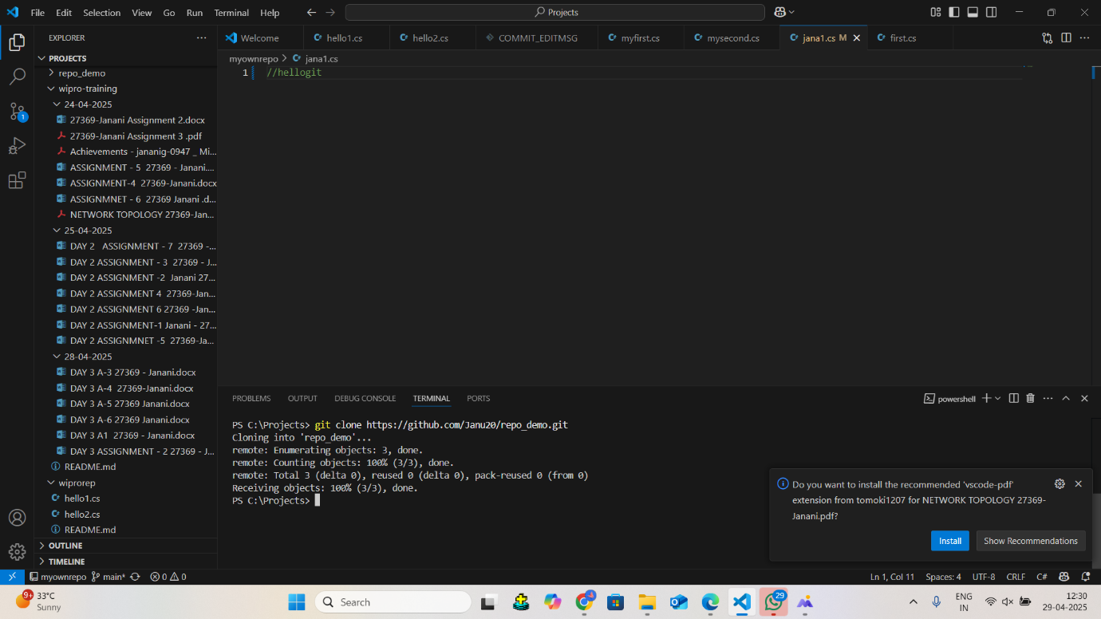

Now we have cloned the repository

**In the below screenshot we can see the repo I have created**

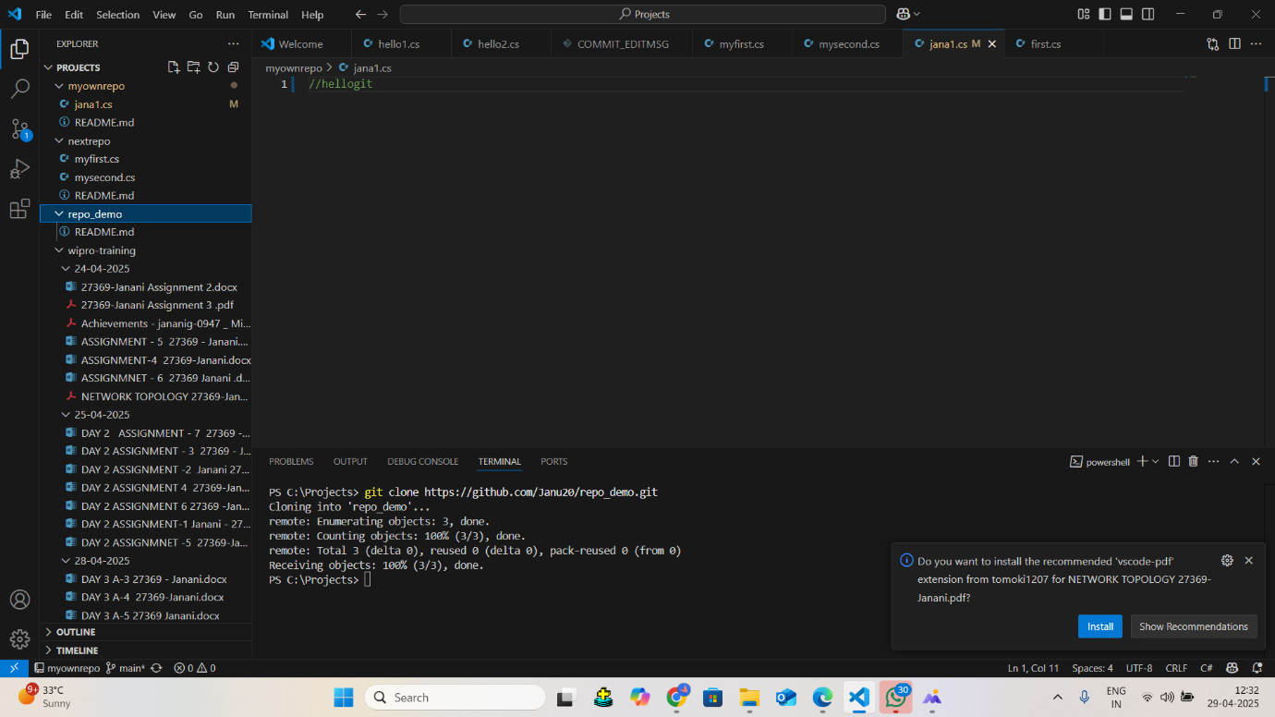

**Creating file in my repo**

I have created a c sharp file “program.cs” in my repository

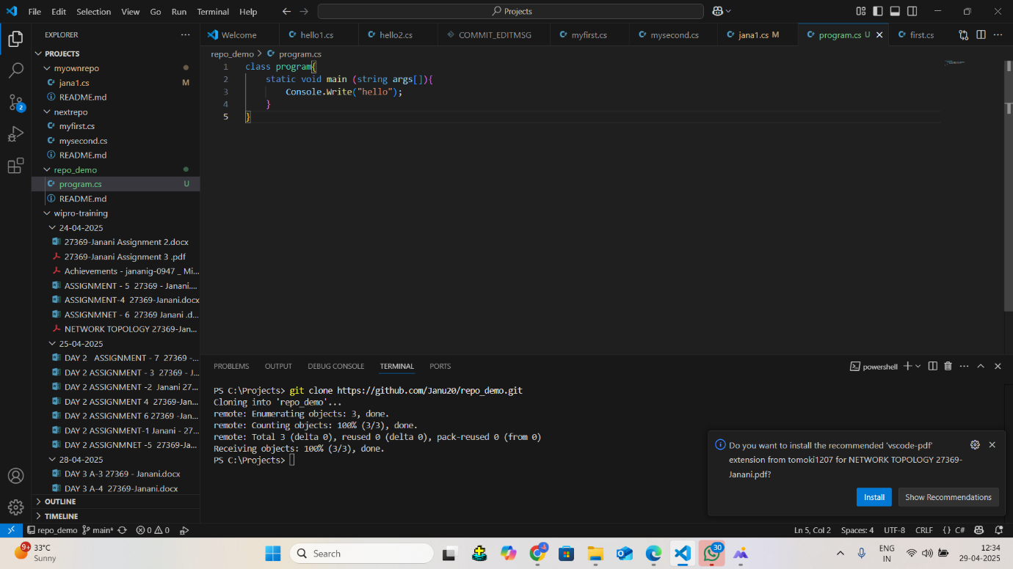

**Commit & push my file I have created :**

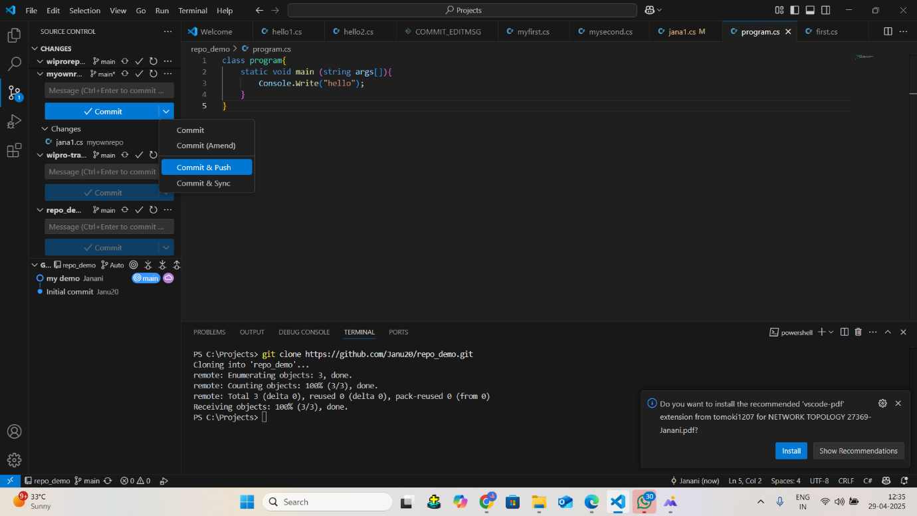

**Now I can see my program.cs file uploaded in my repository in the below screenshot**

